1. **Branch Table:**

create table branch

(branch_name varchar2(20) primary key,

branch_city varchar2(20),

assets varchar2(20));

Output:

Table created.

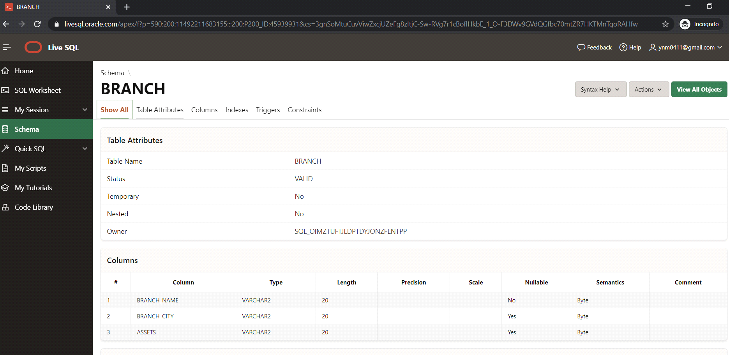

**2) Account Table**

create table Account

(Acc_no varchar2(20) primary key,

branch_name varchar2(20),

balance number(20),

foreign key(branch_name)references branch(branch_name));

Output:

Table created.

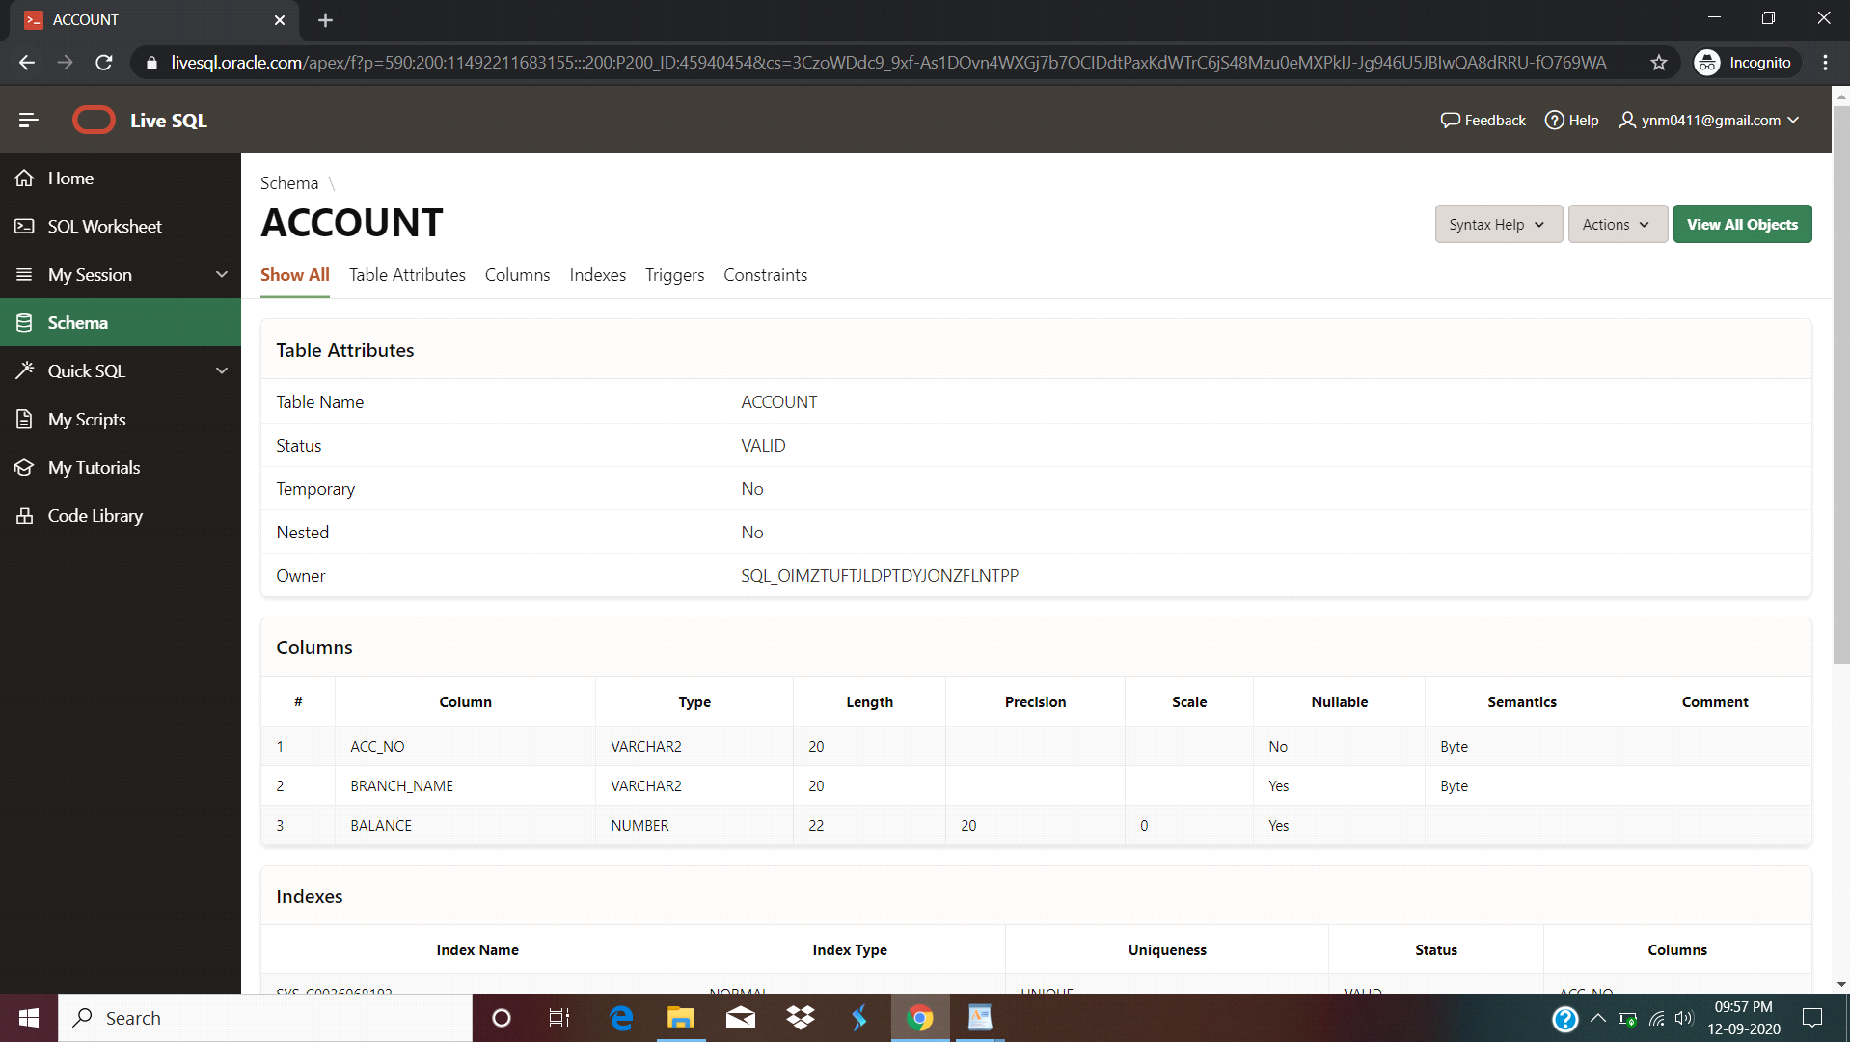

**3) Customer Table**

create table customer

(cust_name varchar2(20) primary key,

cust_street varchar2(20),

cust_city varchar2(20));

**Output:**

Table created.

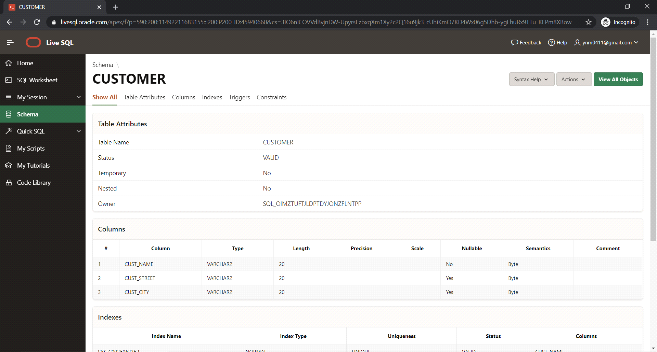

**4)Depositor Table**

create table Depositor

(cust_name varchar2(20),

acc_no varchar2(20),

foreign key(cust_name) references customer(cust_name),

foreign key(acc_no) references Account(Acc_no));

Output:

Table created.

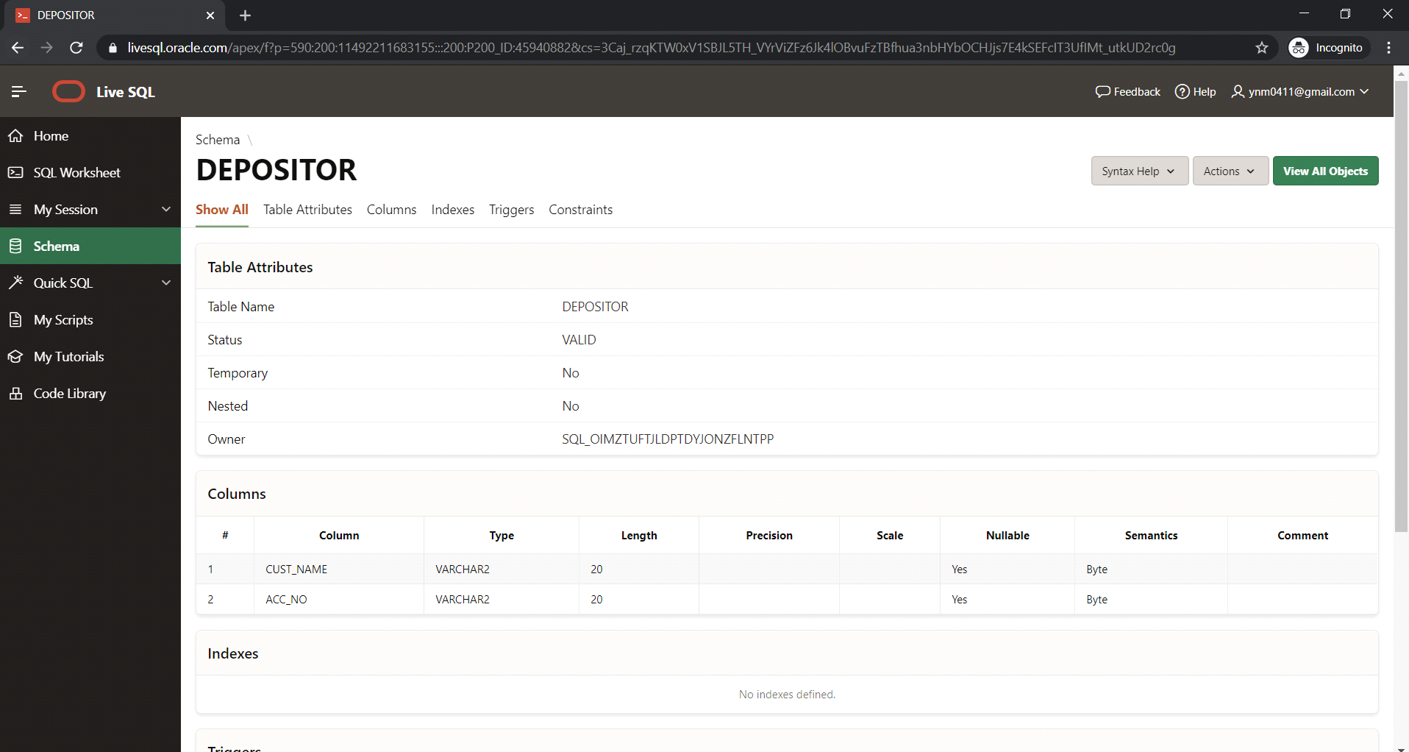

**5)Loan Table**

create table Loan

(loan_no number(20) primary key,

branch_name varchar2(20),

amount number(20),

foreign key(branch_name) references branch(branch_name));

Output:

Table created.

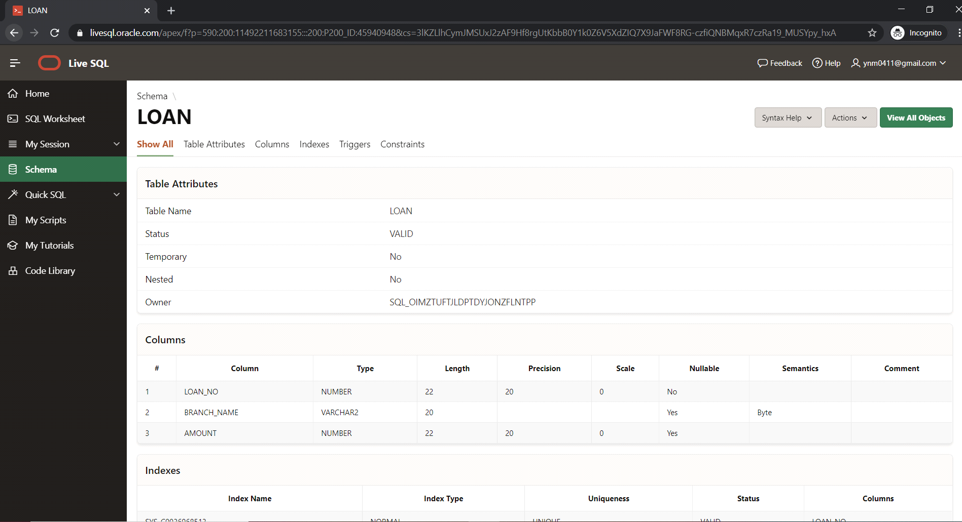

**6) Brrower Table**

create table Brrower

(cust_name varchar2(20),

loan_no number(20),

foreign key(cust_name) references customer(cust_name),

foreign key(loan_no) references Loan(loan_no));

Output:

Table created.

